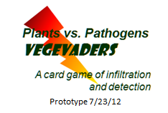
TM

Authors: Bryant Adams, Wells College, Aurora, NY
Candace W. Collmer, Cornell University, Ithaca, NY
Magdalen Lindeberg, Cornell University, Ithaca, NY
Alan Collmer, Cornell University, Ithaca, NY
Funding: Supported by NSF grant # IOS-1025642
Appropriate Level: High School Regents, Honors, or Advanced Placement Biology

Abstract: Playing this game allows students to experience through game-play the continuing co-evolution between plants and their microbial pathogens that occurs during the battle to detect/defend (plants) versus evade/invade (pathogens). This battle is ongoing in nature over evolutionary time and observable in agricultural fields from one season to another, where crop choice or agricultural biotechnology can quickly alter plants in response to changes in pathogen populations. In VegevadersTM, the teacher shows the provided PowerPoint presentation, teaching the underlying biology as well as the rules for game play and scoring, as students begin to play the game. Students play in pairs, plant versus pathogen, on a play mat with 4 sets of cards that represent different pathogen molecules (Rows 1 and 3) or plant receptors (Rows 2 and 4). Card matches represent specific detection events that, for the plant, result in activation of one or the other of the two levels of the plant immune defense response. A pathogen card in Row 3 that matches a plant-pathogen card pair (Rows 1 and 2) can disable the plant defense response and allow pathogen invasion. Alternatively, random mutations (drawing to replace a card) can change pathogen molecules, thus disrupting lock-and-key recognition and allowing invasion, or change the plant’s detection repertoire, restoring detection and successful defense. Game play continues, alternating between card play/scoring and evolution of plant/pathogen, mimicking the rules of the game between plants and pathogens in nature, still playing after millions of years.

Time Required: One 45-minute class period is enough to play a basic version of the game, but a double period (90 minutes) is preferable to allow enough time for playing several seasons of the game and then having a follow-up discussion and wrap-up session. Substantial teacher preparation time for printing play mats and printing/cutting out cards is required the first time the activity is used. After that, minimal teacher preparation time is required. In addition, the teacher will need to review beforehand, and modify if desired, the PowerPoint presentation that is provided to be used with the game.

Key Words: evolution, natural selection; host-parasite interactions, plant immunity, plant disease; receptor, lock-and-key molecular recognition, intracellular signaling, defense response; biotechnology

Living Environment: 4-Content: 1-Living things: 1.1c, d; 2-Organisms inherit genetic information: 2.1i, j; (optional Genetic engineering: 2.2a, b); 3-Change over time: 3.1f, g, h, i; 5-Dynamic equilibrium: 5.1g, 5.2b, c, 5.3a; 6-Ecology: 6.1g

Next Generation Science Standards: HS-LS4 Biological Evolution: Unity and Diversity – Playing this game, a simulation of molecular host-parasite interaction and evolution, will allow students to construct an explanation based on evidence of how natural selection leads to adaptation of populations of plants and their microbial pathogens (HS-LS4-4)

Additional Teacher Information

Basic background Information with which the student must be familiar:

Organisms are made up of molecules, some of which are proteins. Proteins have specific, different shapes from one another.
Two or more different molecules can interact if their shapes match, often via a lock-and-key type fit. This coming together of proteins can be the signal that leads to a response by cell.
Genes in an organism’s DNA contain the information for making specific proteins. A change, or mutation, in a gene usually results in a change to its protein product (and its shape).
Basic tenets of evolution: Variation exists in populations and some of that variation is genetically inherited. Larger numbers of individuals are present than can be supported by the resources available, so therefore there is competition for resources necessary for survival. Those variants best suited to an environment survive and reproduce, passing useful traits on to their offspring. This is natural selection, which over generations results in individuals that are well adapted to a particular environment (in this case, the “environment” is the host-parasite interaction).

Information introduced or reinforced by playing this game:

Plants, like animals, can be afflicted by diseases caused by different kinds of microbial pathogens (for example, bacteria, fungi, viruses). Plant diseases caused by microorganisms cost billions of dollars in crop losses and are a constant threat to the world’s food supply. In addition, plant disease can cause people to die due to lack of food.
Plants, as animals, have a defense system – in this case a two-level immune system to protect themselves by attack from microbes
The battle between plants and pathogens is essentially one of detection and defense on the part of the
plant, versus evasion and invasion on the part of the pathogen.
- How is the battle waged?
  - Pathogens attack plants and try to sneak in undetected to gain resources.
  - Plants have a defense response to protect themselves from pathogen attack.
- The bottom-line of the plant-pathogen battle is detection vs. non-detection.
  - The plant needs to detect the pathogen, using receptors that match specific pathogen molecules. Successful detection turns on the plant’s defense response.
  - The pathogen needs to escape detection – either by avoiding detection (lack of a match with a plant receptor) or by disabling an activated plant defense response.
- This constant battle between detection by the plant, and evasion by the pathogen, drives the evolution of each – in both the natural world over millions and millions of years, and in an agricultural crop field each season.
  - Evolution drives the selection for plants that contain ever more sophisticated detection and defense machinery
  - Evolution drives the selection of pathogens that have either lost what was detected by the plant (defense), or acquired new machinery that disables the plant’s defense response (offense).
All organisms, including plants and microorganisms, change over time via natural or artificial selection to allow them to survive in the environment in which they are living.
The game VegevadersTM mimics the ongoing game between plants and pathogens that’s been playing in nature for millions of years.

The Game VegevadersTM -- A Brief Description of Game Play
(a more detailed description is given in the PowerPoint presentation)

OVERVIEW - In the game VEGEVADERS, two students (1 Plant and 1 Pathogen) each play eight unique cards on a play mat, representing 1 agricultural season in 1 plant. The 16 played cards are scored to determine whether the Plant or Pathogen player wins for that season. The winning hand will remain as is to play another season; the losing hand will “die” and be replaced by a variant in the population that can survive. Evolution drives the selection for this genetically altered former “loser,” which will play against the winner of the previous season when the 2 players meet to battle again in the next season.

PLAYING
1) The Pathogen plays 4 different Microbial Feature cards in Row 1 of the play mat.
2) The Plant then plays 4 different Surface Receptor cards in Row 2 of the play mat.
Do any card letters match between Rows 1 and 2? If there are two or more matches, the plant has detected the pathogen and the plant is winning (so far) by Microbial Feature-Triggered Immunity (MTI) – as shown on figure of play mat with 8 cards played so far:
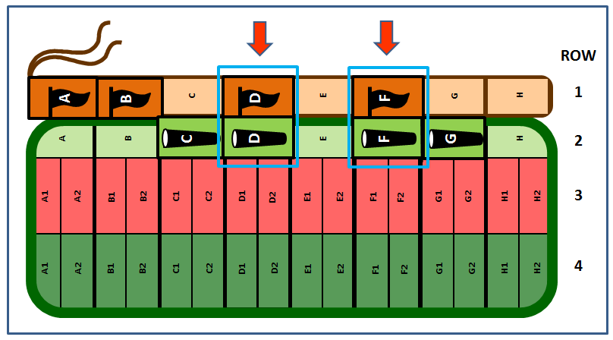
3) The Pathogen then plays 4 Effector cards in Row 3 of the play mat.
Do any of the Effector cards match the letter of a Surface Receptor that is matching a Microbial Feature? If so, the Surface Receptor-Microbial Feature match is disabled and no longer counts toward MTI.
4) The Plant then plays 4 Resistance Protein cards in Row 4.
If at least one Resistance Protein matches an Effector by both letter and number, the plant wins by Effector-Triggered Immunity (ETI), which trumps MTI.

SCORING - If the Plant has detected the Pathogen via MTI or ETI, the Plant wins 1 point.
If the Plant has not detected the Pathogen or if disabling has reduced the MTI matches to fewer than 2, the Pathogen wins 1 point.
EVOLUTION – the Loser for that season dies, and evolution selects for a genetically altered “loser” to appear next season.
If Pathogen wins, a new Plant cultivar is grown next season: Randomly choose and discard 2 R-protein cards of the 4 in play. Replace them on the mat with 2 new R-protein cards drawn from the deck.
If Plant wins, Evolution selects for a genetically altered Pathogen: Discard 1 Pathogen card, randomly, from any that were involved in an active match (not disabled) and thus were responsible for the Plant winning by ETI OR MTI, not both. If plant achieved both ETI and MTI, use ETI. Replace any discarded card with a new one from the corresponding deck.
All other cards, except those changed via evolution, remain on the mat in play.

Score a new season with the new cards, and continue playing for as many seasons as desired.
Additional Background Information for Teachers

The game VegevadersTM mimics a real game that has been playing continuously in nature since before the dawn of agriculture. In this game, plants and their potential pathogens continually co-evolve as they wage an ongoing battle of invasion versus detection/defense, offense versus defense, with neither side ever winning for long. Helping students to catch a glimpse of this real game is the goal of VegevadersTM . When it succeeds, it can delight and amaze.

Like animals, plants have an active immune system that protects them against microbial pathogens. It is made up of two levels. The first level operates at the surface of the cell, where different protein molecules (Receptors) in the plant cell membrane recognize different physical features on the outside of microbes. The molecules recognized are known as Microbial Features. Examples of such Microbial Features include proteins in the bacterial flagella (whip-like structures required for mobility), and molecules that make up the cell walls of bacteria or fungi. The plant surface Receptors recognize the individual Microbial Features based on a specific lock-and-key fit between the molecules. Such recognition leads to signaling inside the plant cell that turns on genes in the nucleus and produces defense responses, which limit microbial growth and colonization. Examples of some of these defense responses include the deposit of material just inside plant cell wall, resulting in an thicker protective barrier, and the secretion of small, anti-microbial proteins and highly reactive oxygen molecules, both capable of damaging threatening pathogens. This first level of plant immunity is called Microbe Feature- Triggered Immunity, or MTI.
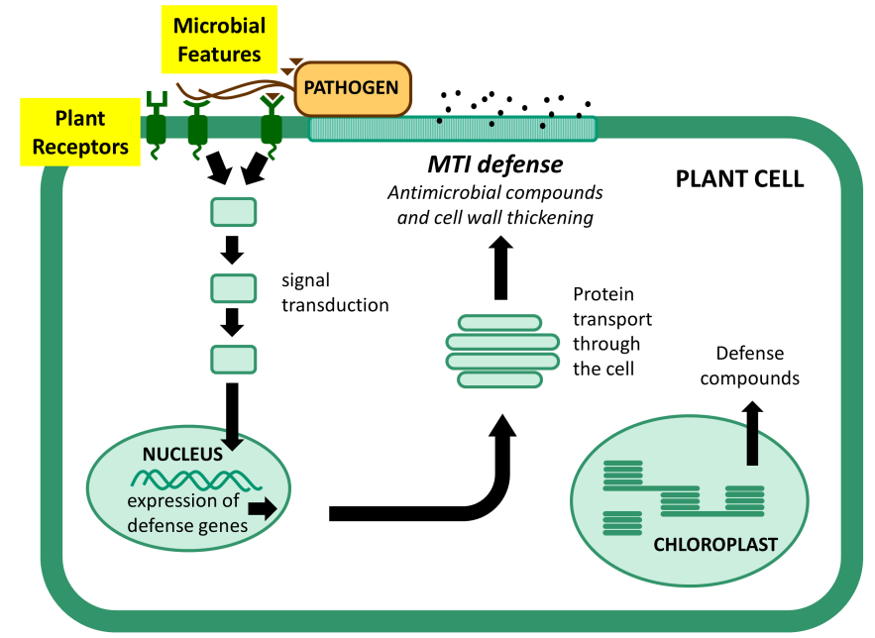

However, successful pathogens defeat this first level of plant immunity by injecting sets of Effector molecules inside the plant cell. A set can include hundreds of Effectors with fungal pathogens, or fewer than 50 for bacterial pathogens, and which particular set is injected can vary significantly among different variants of similar pathogens. The different Effector molecules disrupt plant defense by sabotaging different steps in signaling and response, and the diversity of biochemical mechanisms by which Effectors act continues to amaze research scientists who study them. For example, one bacterial effector acts as an enzyme (i.e. a protease) that directly degrades a specific plant molecule that triggers the plant defense response. Another mimics a plant enzyme in attaching to a different plant signaling protein a tag that directs the plant itself to chew up this essential defense molecule. A third Effector disrupts the delivery system by which the plant cell moves defense molecules to the cell’s surface for secretion. Collectively, pathogen effectors are essential for a range of different pathogens, including bacteria, fungi, oomycetes, and parasitic worms. Effectors successfully suppress the first line of plant defense, MTI, which then allows for pathogen invasion and, ultimately, plant disease.

It should come as no surprise that across evolutionary time, plants acquired a second level of defense focused on detecting these injected Effectors. And, as above, detection leads to a response – in this case a strong, ultimate plant defense response. Effectors are detected by plant intracellular receptors, known as Resistance proteins (or R-proteins). Their interaction involves a specific lock-and-key recognition, which triggers a strong hypersensitive response known as Effector-Triggered Immunity, or ETI. ETI often involves the death of cells (necrosis) near the infection site, so that the pathogen, which needs living plant cells to survive, can no longer spread. Individual plants deploy large numbers of different intracellular Resistance proteins, each of which is capable of recognizing a different pathogen effector. In fact, genes that code for R-proteins are the most variable class of genes in a plant’s genome!

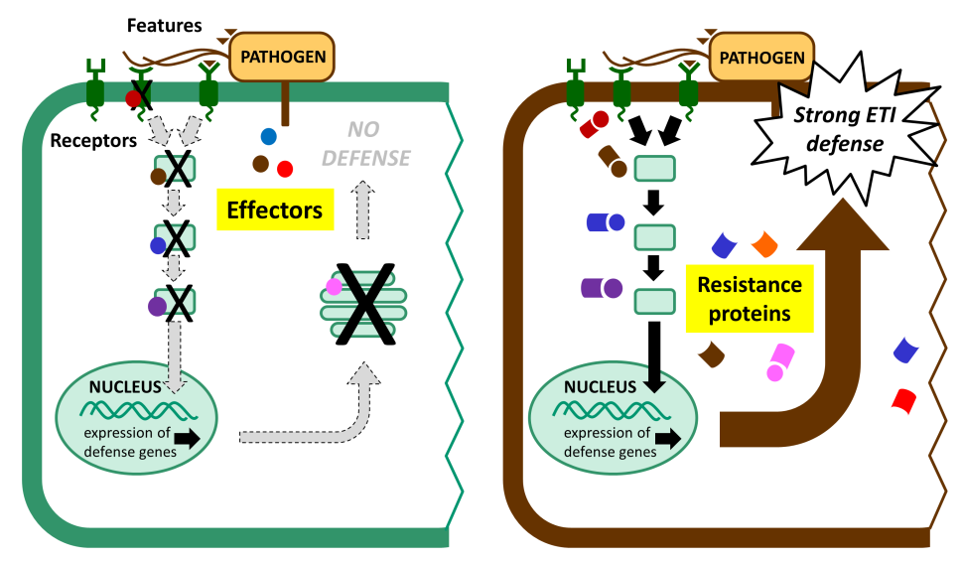

The life-or-death struggle for the plant to detect and the microbe to evade detection sets the stage for continuous co-evolution between pathogen and plant. New pathogen variants, with altered (i.e. mutated) effectors that no longer match specific plant R-proteins, are able to invade those plants undetected. Those pathogen variants will survive and reproduce – natural selection in action – leading to changes in the pathogen population over time. Sometimes we can even see pathogen evolution occurring during a single agricultural growing season! The rapid change possible within pathogens is plainly visible when we look at the genome sequences of related pathogen variants. It is not uncommon to see effector genes disrupted by point mutation or by insertion of a large transposable element, resulting in the loss of the encoded protein. The same kinds of rapid changes in pathogen genomes occur in hospital settings, where selection for populations of pathogens resistant to multiple antibiotics occurs, leading to the current problems with multiple-drug-resistant (MDR) organisms. In bacterial pathogens of either plants or animals, new genes can be acquired on plasmids via horizontal gene transfer (HGT) from related or even non-related organisms.

On the plant side, the appearance of a pathogen that is undetectable, and thus pathogenic, will typically select for plants variants that have acquired a new Resistance gene that matches some different pathogen molecule and thus turns on a successful plant defense. Those plants will survive, and reproduce. Plants in nature acquire new Resistance genes via standard cross-pollination. Plant breeders working to develop crop plants for agricultural fields can create new, resistant cultivars through cross-breeding or by using biotechnology (genetic engineering). Thus the arms race between plant and pathogen continues.
Supplies Needed and Helpful Hints

Supplies needed – the files for the Introductory PowerPoint Presentation, the play mat, and the cards will be available for download at the Pseudomonas-Plant Interaction website:
http://pseudomonas-syringae.org/

For the whole class:
PowerPoint Presentation – This is meant to be presented by teachers to the class as the game is taught and played in the classroom, and it may be modified to suit particular teacher needs. It explains the biology underlying the molecular battle between plants and their would-be microbial pathogens (detection/defense vs. evasion/invasion) as well as how to play and score the game.

Per team of 2 students:
Play mat with 2 attached, sliding paperclips (red and green, if available) to keep score
1 red and 1 green paperclip, attached to the mat as indicated above
Plastic sleeve in which the play mat is inserted
4 different decks of cards (96 cards total) -- 2 decks for the plant player (light green and dark green), 2 decks for the pathogen player (light orange and dark orange) – to be printed and cut out by teacher

Helpful Hints:

The PowerPoint Presentation should be saved to the teaching computer and then modified as desired by the teacher according to individual classroom needs. It is designed to teach both the teacher (ahead of time), and then the students when it is presented to the class as students play the game. It illustrates in cartoon form the underlying biology as well as the rules for playing, scoring, and evolving during game play.

Play mats are needed for each pair of students. Each play mat should be printed on a sheet of white, 11 x 17 paper, and then inserted within 12 x 18 plastic sleeves that open on 3 sides. (These are available at Staples where they are used for lamination; however, don’t have them fused; instead, keep them open so the printed mats can be slipped in and out of the sleeves.) Insert the mat so that the victory point scales are along the closed end of the sleeve. Attach red and green paper clips (or metal, if colored ones are not available) to the closed end of the sleeve, so that they can slide along the victory point scales to keep the scores for the two players.

Playing cards can be produced by printing the playing card file. For each pair of students, the 6 page file must be printed double-side onto sheets of letter-size, white card stock (i.e. heavy paper). That will create 3 sheets of cards with appropriately colored backs that then need to be cut up to generate the 96 cards, divided among two decks of 16 cards each (light orange and light green) and 2 decks of 32 cards each (dark orange and dark green). These should be grouped, following cutting, into the 4 different decks and then shuffled well before setting up to play the game

Arranging the classroom to play the game should be done so that every student can easily see the PowerPoint presentation as well as the play mat and her/his two stacks of cards.
1) If tables are perpendicular to the front of the room where the screen is located, paired students can sit across from each other with the mat in between, and both students can easily see the PowerPoint. In this case, the two decks of well-shuffled cards for both the plant player (light and dark green cards) and the pathogen player (light and dark orange cards) should be placed separately, face down, on the table between the student and the mat (i.e. off the mat).
2) If tables are parallel to the front of the room, then we suggest having the students sit on the same side of the table, facing forward, with the mat in between them and perpendicular to the table’s orientation, and with two decks of cards in front of each student (as shown in figure).

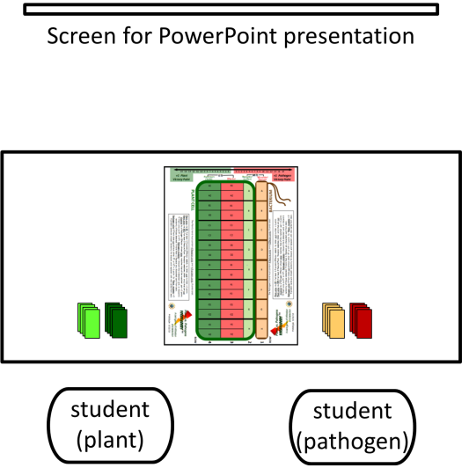

To play the game, the teacher should narrate and present the PowerPoint presentation to the class; when the teacher begins, the students should be set up and ready to play the game. The presentation first introduces plant disease and shows the underlying biology of plant-pathogen interactions, along with a castle vs. invaders metaphor that helps students remember the concepts. The play mat and cards are introduced in the context of the metaphor, and students are led play-by-play to lay down cards sequentially on the four rows of their mats. Students practice determining as they go along whether the plant or the pathogen is currently winning after each row is played. The presentation explains the rules for scoring at the end of one round of play (which simulates one season in an agricultural field), as well as the rules for evolution of the plant or pathogen between seasons. Once the students have practiced playing long enough to fully understand how to play the game, the individual pairs play and score on their own for as many seasons as time allows. Once game play is complete, the teacher assembles a class tally for the number of wins by both plant and pathogen across the class as a whole. Individual pairs of students, or the class as a whole, can answer the Discussion Questions suggested in the PowerPoint presentation, and the class period ends with a Wrap-up Session led by the teacher and facilitated by the PowerPoint presentation.

Some Possible Discussion Questions, and Answers, to use after playing VegevadersTM

Open-ended questions:
1. What did you learn about plants from playing VegevadersTM? Did you learn anything new that you didn’t know before?

2. What did you learn about evolution from playing VegevadersTM? Did you learn anything you didn’t know before?

Review and/or Ponder Questions:
1. A Plant can win a season by achieving either ETI or MTI. Biologically speaking, what is happening in a real plant out in a real field when it “wins” against a potential pathogen?
The Plant detects the Pathogen via a lock-and-key recognition between a plant receptor and a pathogen molecule. Detection by the Plant turns on a Plant defense (immune) response, which prevents the Pathogen from invading and colonizing the Plant.

2. In light of 1) above, what are 2 underlying mechanisms by which a Pathogen can “win”?
A Pathogen can win
a) by evading detection by the Plant (i.e. no molecular recognition) OR
b) by disabling the Plant’s defense response against it (a response that was turned on following the detection by a Plant receptor of a Pathogen molecule, such as a Pathogen effector injected inside a plant cell).

3. If a plant cultivar can detect the presence of a potential pathogen, it is normally resistant to attack by that microbe. What kind of selective pressure does this exert on the pathogen population, and how, specifically, is the pathogen population likely to change in response?
There would be pressure to change the molecule(s) of the Pathogen that are recognized, so that the Pathogen would escape detection and the resulting plant defense response. Plant Resistance genes drive the loss (or mutation) of Pathogen Effectors, and Plant Receptors drive the loss (or mutation) of Pathogen Features).

4. There is evidence in Pathogen genomes that shows the mutation and loss of genes that code for specific Effectors. But if Effectors are lost, a bacterial pathogen needs to acquire a new Effector to suppress the Plant’s immune (defense) response. How does this happen? (HINT: Consider the increasing problem with microbial resistance to antibiotics now being seen in hospitals and other health care settings.)
Via Horizontal Gene Transfer (HGT) – genes are transferred from bacterium to bacterium on plasmids, and genes move around in bacterial DNA via transposons. These same processes happen within bacterial pathogens of humans found in hospital settings, in this case with genes for resistance to antibiotics.

5. How do Plants acquire a new Resistance gene, whose protein product can recognize a new Pathogen molecule (such as a new effector)?
Just as animals have an antibody that can recognize any new pathogen molecule that shows up, so there is likely to be a plant out in nature (a “wild relative”) that has the needed R gene, which was shaped by millions of years of evolutionary pressure from microbial effectors. Such new R genes can move into a plant:
a) in nature via cross-pollination and standard genetic recombination between genomes, or
b) in agriculture via plant breeders who find and then move the R gene from wild relatives into the desired agronomic cultivar. They can do this either by planned cross-breeding or by using biotechnology and genetic engineering.

6. In terms of evolution, how is a farmer’s field different from the natural world, and how might that affect pathogen evolution?
A farmer’s field is often planted in a monoculture, where all Plants growing there have the same genetic make-up. If the Pathogen population present is detected by every crop Plant, and thus prevented from invading and surviving anywhere in that field, there will be strong selective pressure for the appearance of a Pathogen variant that has lost (through mutation) the detected molecule. Since this variant is invisible to the plant, it will invade, multiply, produce offspring, and spread, often causing acres of plant disease. This accounts for the classic “boom and bust” cycles seen in modern, large-scale agriculture. The “boom” in crop harvests returns when a new, resistant variety of the crop is planted, thwarting the Pathogen for a limited period of time, until evolution once again selects for the appearance of an invisible variant, which is able to invade………

Note: Frequently asked questions (FAQs) and their answers, will be available at the PPI website (http://pseudomonas-syringae.org/)

Plants vs. Pathogens: VegevadersTM
New York State Learning Standards

Standard 4: Content:
Key Idea 1: Living things are both similar to and different from each other and from nonliving things.
1.1 Explain how diversity of populations within ecosystems relates to the stability of ecosystems
By playing the game VegevadersTM, students see how populations of plants and their pathogens continually change in response to each other during the never-ending battle to defend versus invade. Variants within plant or pathogen populations survive when others fail in the competition, allowing for stability of the ecosystem while the individuals within it change.
Key Idea 2: Organisms inherit genetic information in a variety of ways that result in continuity of structure and function between parents and offspring
2.1 Explain how the structure and replication of genetic material result in offspring that resemble their parents.
Students playing the game will see how molecular interactions between plants and pathogens are determined by their proteins, which have specific shapes that do or do not allow for a lock-and-key fit that determines recognition. Genes that code for these specific proteins are passed to offspring, which are similar to their parents unless mutation changes genes, and thus proteins.
2.2 (optional) Explain how the technique of genetic engineering allows humans to alter genetic makeup of organisms
The teacher can use the game, if desired, as an opportunity to explain to students how plant breeders would use genetic engineering to add a needed plant Resistance gene to a crop plant, thus creating a new plant cultivar that would be resistant to a destructive microbial pathogen present in, or threatening, crop fields.
Key Idea 3: Individual organisms and species change over time.
3.1 Explain the mechanisms and patterns of evolution.
Through game play, students see that genetic variants in populations, which escape plant detection and cause disease (pathogens), or successfully detect and mount an effective defense (plants), survive. These organisms reproduce and pass on the essential traits to offspring. Thus populations change in response to natural selection, and the never ending, back-and-forth coevolution between plants and their pathogens continues.
Key Idea 5: Organisms maintain a dynamic equilibrium that sustains life.
5.1 Explain the basic biochemical processes in living organisms and their importance in maintaining dynamic equilibrium.
In playing VegevadersTM students see that the underlying biochemical process that determines whether a plant defends, or a pathogen invades, is the lock-and-key fit that allows the molecular interaction between plant receptors and specific pathogen molecules (antigens). Only when specific shapes match can molecules interact.
5.2 Explain disease as a failure of homeostasis, and
5.3 Relate processes at the system level to the cellular level in order to explain dynamic equilibrium in multicellular organisms
Through playing VegevadersTM, students see how microbes infect plants and cause disease when they are able to disable the plant’s immune defense system. This plant defense system depends on detection of a microbial molecule, which activates intracellular signaling and leads to a plant defense response that can spread to nearby cells. Such a response can be visible at the organismal level. Pathogen invasion depends on evading detection or actively interfering with the plant’s defense response.
Key Idea 6: Plants and animals depend on each other and their physical environment.
6.1 Explain factors that limit growth of individuals or populations.
Playing VegevadersTM gives students an up-close look at the back-and-forth molecular dynamics of a parasite-host relationship, where each participant evolves in a constant struggle to keep the other in check. When the parasite wins, it becomes a pathogen and plant disease results.

